Task groups are groups of individuals brought together to accomplish a specific action or produce a product

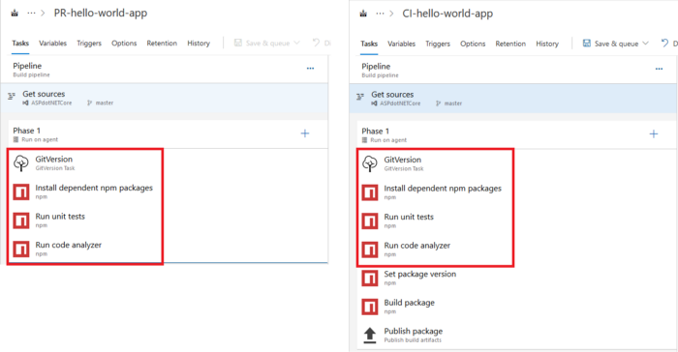

If you take the example of the above shown pipelines, the first four tasks are common to both definitions. In case there is a need for modifying one of the tasks (or remove/add a common task), the change has to be separately applied to both definitions. Now think about it at a larger scale, where there are many pipelines and you have to modify each one’s definition.

This is where Azure Pipeline’s **Task Groups**come in handy. Task Group, as the name suggests, groups a common set of tasks into one single task. Multiple pipelines can now use this new task instead of repeating the steps all over again. Creating task groups is very easy. Just select the tasks that you want to group and choose “Create task group” from the context menu. A popup appears, enter name and description and select category under which this new task should appear and click on the “Create” button. It is also possible to create a task group that encapsulates other task groups.